 | Sanjivani Rural Educational Society’s SANJIVANI COLLEGE OF ENGINEERING  (An Autonomous Institution)  Kopargaon – 423 603, Maharashtra. | ACAD-F-15 K
Academic Year: 2025-26 | CIA ACTIVITY REPORT | Revision: 00 Dated :
Department : IT | Information Technology | Date of  Preparation : 7-10-2025
Course Code & Name: | CO401: Software Enginnering modeling and desgin | Year/Sem:  S.Y IV

Activity Title:

Restaurant Management System

Submitted by:

Roll  No. | PRN No. | Name of the Student | Signature
123 | 0124UITF1123 | Charvande Shivani Radhakisan
124 | 0124UITF1124 | Dange Shraddha Ramesh
125 | 0124UITM1125 | Gore Aditya Mayur
126 | 0124UITM1126 | Laware Kunal

Course Incharge
Dr. S. N. Gunjal

INDEX

Sr.No. | Topic | Page no.
 | Abstract
 | Project Definition
 | Introduction
 | Scope of the Project
 | Objectives of the Project
 | Literature Review / Background Study
System Analysis
7.1 Existing System
7.2 Problems in Existing System
7.3 Proposed System
Software Requirements Specification (SRS)
8.1 Functional Requirements
8.2 Non-Functional Requirements
8.3 Use Case Diagram
8.4 Use Case Description
System Design
9.1 UML Diagrams
- Class Diagram
- Sequence Diagram
- Activity Diagram
- Sate chart Diagram
- Collaboration Diagram
- Component Diagram
- Deployment Diagram

 | Data Flow Diagram (DFD)
 | Control Flow Diagram(CFD)
 | Conclusion
 | References

1. Abstract

Restaurant management plays an important role in providing efficient customer service
and managing daily operations. In many restaurants, activities such as order taking, billing,
table management, and maintaining records are handled manually. This manual system
often leads to errors, slow service, poor record management, and customer dissatisfaction.
To overcome these problems, a Restaurant Management System is proposed. This system
provides a centralized digital platform to manage restaurant activities efficiently. It helps in
managing menu items, taking customer orders, generating bills, managing payments, and
maintaining records.
The system allows staff to take orders digitally and send them directly to the kitchen. It also
generates bills automatically and stores customer data securely. The Restaurant
Management System reduces manual work, improves accuracy, and increases service speed.
Overall, it enhances customer satisfaction and improves restaurant efficiency.

2.Project Defination

The Restaurant Management System is a web-based application designed to automate
restaurant operations. It helps in managing orders, billing, menu items, customers, staff, and
reports.
The system provides an easy-to-use interface for restaurant staff and administrators.
It reduces manual work and improves service quality.

3.Introduction

Restaurants need proper management to handle daily operations efficiently. These
operations include order taking, billing, customer service, and record management. In
traditional restaurants, these tasks are done manually which leads to errors and delays.
Manual systems make it difficult to track orders, manage tables, and generate reports. With
the help of technology, these operations can be automated.
The Restaurant Management System provides a digital solution to manage restaurant
operations. It allows staff to take orders digitally, send them to the kitchen, and generate
bills automatically. This improves service speed and customer satisfaction.

4.Scope of Project

• Order Management – The system manages customer orders including placing, updating,
and tracking orders.
• Menu Management – The system allows adding, updating, and deleting menu items.
• Billing System – The system generates bills automatically for customer orders.
• Customer Management – The system maintains customer details and order history.
• Staff Management – The system manages staff information and roles.
• Table Management – The system manages table availability and reservations.
• Payment Management – The system processes payments using multiple methods.
• Report Generation – The system generates reports for sales and performance analysis.

5.Objectives of the Project

• To automate restaurant operations
• To reduce manual work
• To improve customer service
• To generate bills automatically
• To manage menu efficiently
• To maintain records digitally
• To generate reports

6.Literature Review / Background Study

Existing systems in many restaurants rely on manual order taking and paper-based billing.
Some restaurants use basic digital tools like spreadsheets, which lack automation and real-
time updates. These traditional systems often lead to errors, slow service, and poor record
management.
Modern restaurant management systems use web-based platforms to:
• Maintain centralized data
• Automate order processing
• Generate bills automatically
• Track orders in real-time
• Improve customer service
However, many existing systems are expensive, complex, or difficult to use. Hence, this
project aims to develop a simple, efficient, and user-friendly Restaurant Management
System.

7.System Analysis

7.1 Existing System
- Manual order taking
- Paper-based billing
- No centralized system
- Manual record keeping

7.2 Problems in Existing System
- Manual order taking leads to errors
- Slow service and long waiting time
- Poor record management
- No real-time order tracking
- Difficulty in managing tables
- Billing errors and delays
- Lack of proper report generation

7.3 Proposed System
The proposed system introduces a digital platform that:
- Stores all restaurant data securely
- Allows digital order management
- Tracks orders in real-time
- Generates bills automatically
- Manages tables efficiently
- Processes payments quickly
- Generates reports

8.Software Requirements Specification (SRS)

8.1 Functional Requirements
- FR: The system shall allow user login.
- FR: The system shall allow admin login
- FR: The system shall manage menu items
- FR: The system shall allow order placement
- FR: The system shall modify orders
- FR: The system shall cancel orders
- FR: The system shall generate bills
- FR: The system shall process payments
- FR: The system shall manage customers
- FR: The system shall manage staff
- FR: The system shall track orders
- FR: The system shall generate reports
- FR: The system shall update order status

8.2 Non-Functional Requirements
- NFR: The system shall be user-friendly and easy to use.
- NFR: The system shall ensure secure data storage and user authentication.
- NFR: The system shall provide fast response time.
- NFR: The system shall be reliable with minimal downtime.
- NFR: The system shall be scalable to handle increasing users and data.
- NFR: The system shall maintain data accuracy and consistency.

8.3 Use Case Diagram

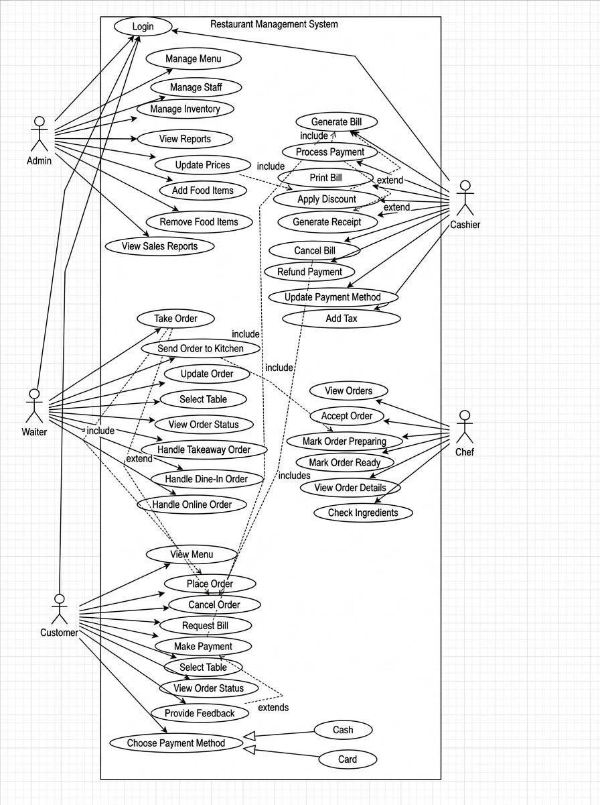

8.4 Use Case Description

The Restaurant Management System is designed to automate and manage the overall
operations of a restaurant by involving different users such as Admin, Waiter, Customer,
Cashier, and Chef. The admin is responsible for managing the entire system and performs
functions such as login, managing menu items, managing staff, managing inventory,
updating prices, adding and removing food items, and viewing reports including sales
reports. The Waiter plays an important role in handling customer orders by taking orders,
sending them to the kitchen, updating orders when required, selecting tables, viewing order
status, and handling dine-in, takeaway, and online orders. The Customer interacts with the
system by viewing the menu, placing orders, cancelling orders, selecting tables, requesting
bills, making payments, viewing order status, and providing feedback. Customers can also
choose their preferred payment method such as cash or card.

The Cashier manages billing and payment-related operations. The cashier generates bills,
processes payments, prints bills, applies discounts, generates receipts, cancels bills, refunds
payments, updates payment methods, and adds taxes. The Chef is responsible for kitchen-
related activities and handles food preparation tasks. The chef views incoming orders,
accepts orders, checks ingredients, views order details, marks orders as preparing, and
finally marks orders, checks ingredients, views order details, marks orders as preparing, and
finally marks orders as ready.
The system also includes relationships such as include and extend, where certain
Functionalities depend on others. For example, taking an order includes sending the order to
the kitchen, generating a bill includes processing payment, and applying discounts extends
bill generation. This system helps improve efficiency, reduce manual work, provide faster
service, and enhance customer satisfaction by automating restaurant operations.

9.System Design
9.1 UML Diagrams

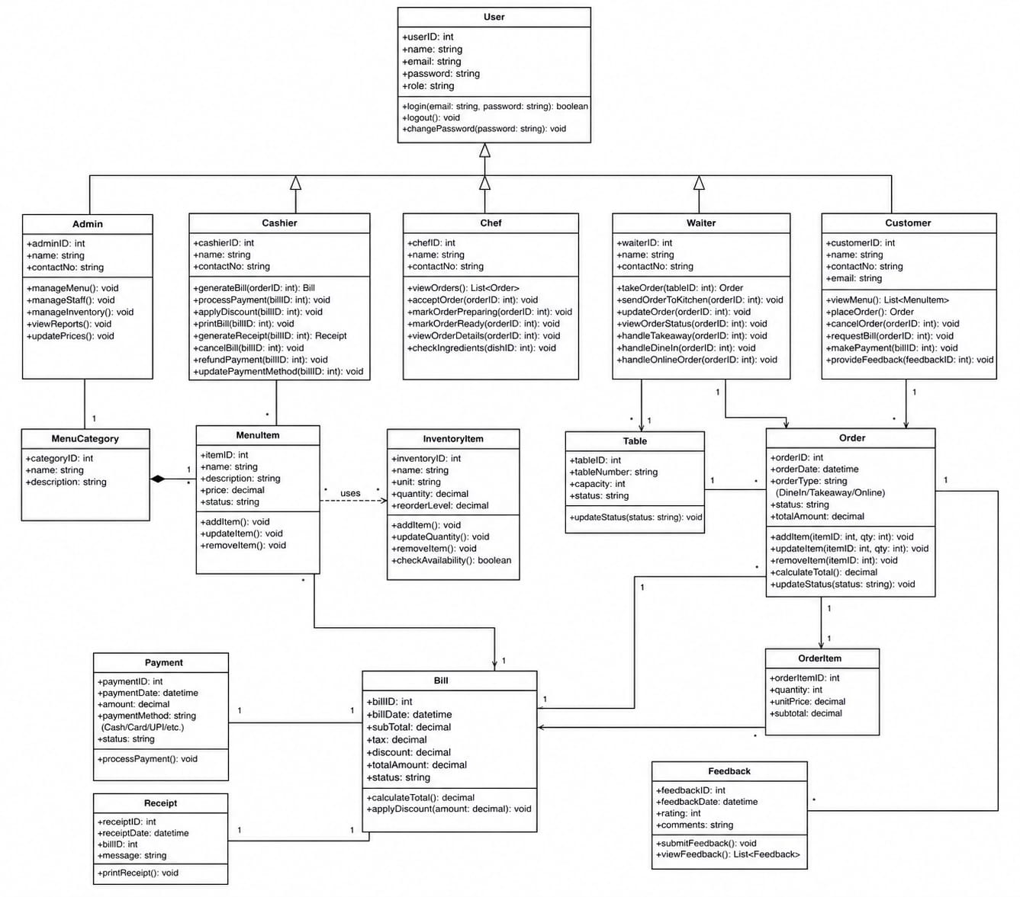
1.Class Diagram

Descripition:

This class diagram represents the structure of a restaurant system showing different users like
Admin, Cashier, Chef, Waiter, and Customer, all derived from a common User class. It
includes main entities such as Order, MenuItem, Table, Bill, and Payment, along with their
attributes and functions. The relationships between classes show how orders are created,
processed, billed, and managed within the system.
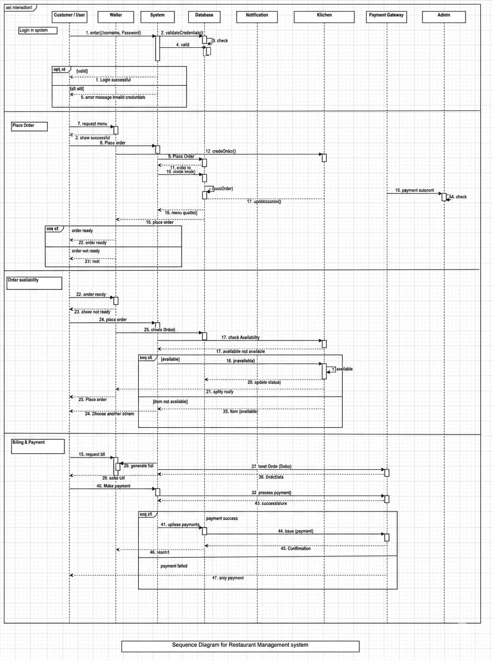
2.Sequence Diagram

Sequence Diagram Descripition:

The sequence diagram for the Restaurant Management System shows the interaction
between customer, waiter, system, kitchen, database, and payment gateway. The process
includes user login, placing an order, checking item availability, preparing food, generating
the bill, and processing payment. Finally, the system confirms the order and completes the
transaction.

3.Activity Diagram

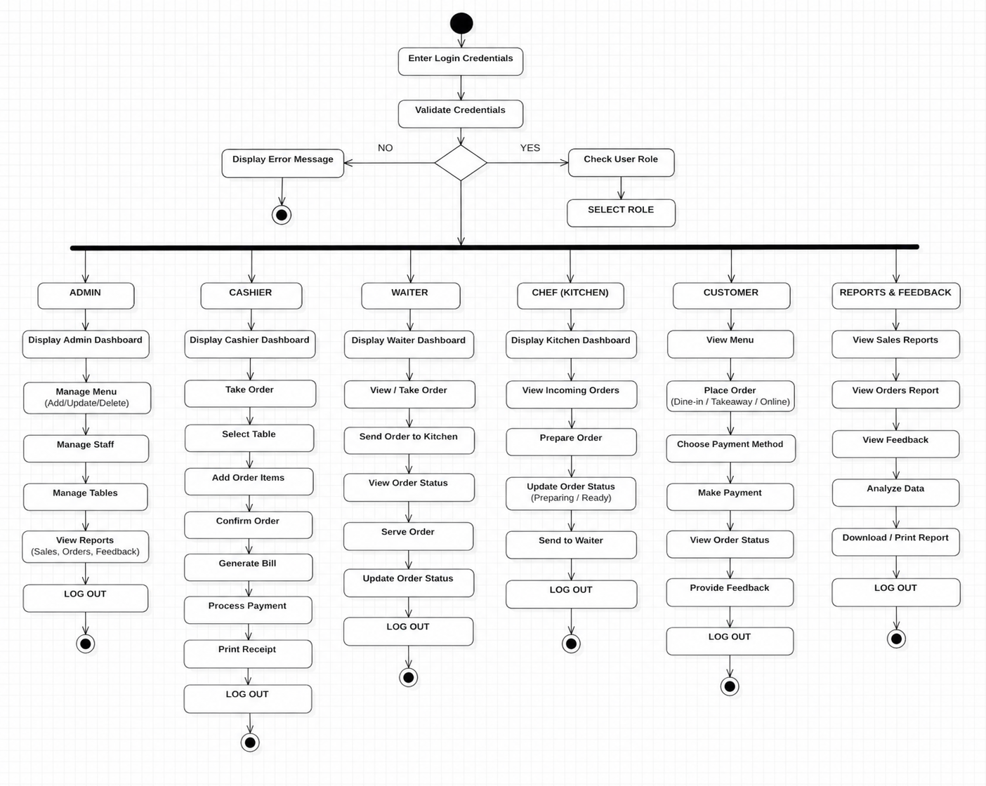

Activity Diagram Descripition:

This activity diagram shows the workflow of a restaurant system divided into different roles
like Admin, Cashier, Waiter, Chef, and Customer. Each lane represents the responsibilities
and sequence of actions performed by that role, such as order processing, food preparation,
and payment handling. It clearly shows how tasks flow between roles and how the system
coordinates the complete restaurant operation.

4. State Chart Diagram
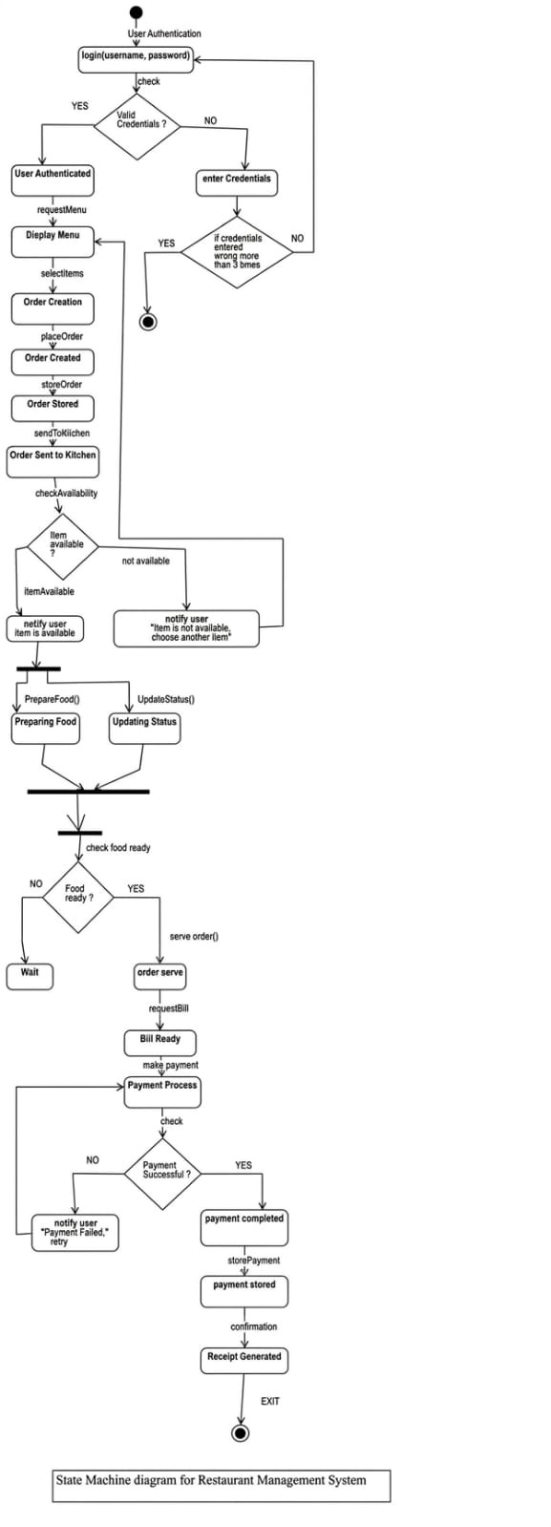

Descripition:
The state machine diagram for the Restaurant Management System shows the flow of activities from user authentication to payment completion. The process begins with user login, where credentials are validated; if valid, the user proceeds to view the menu and place an order. The system checks item availability, prepares food, and updates order status. After serving the order, the bill is generated, payment is processed, and upon successful payment, the receipt is generated and the process ends.

5. Collaboration Diagram

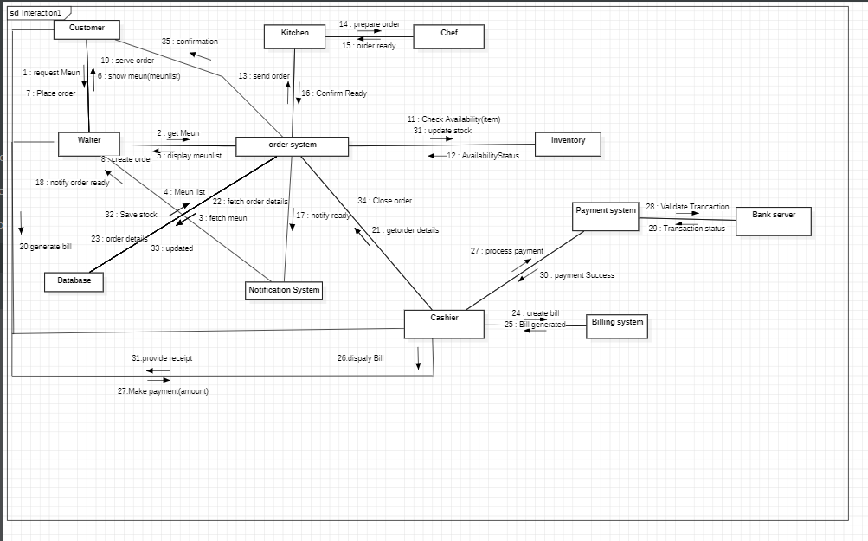

Descripition:

The diagram illustrates the communication flow in a restaurant management system
involving multiple components. A customer places an order through the waiter, which is
processed by the order system and forwarded to the kitchen for preparation. The system
also interacts with inventory and database modules to check availability and update stock.
Finally, the billing and payment systems handle transactions, and the cashier generates the
bill and provides the receipt to complete the process.

6.Component Diagram

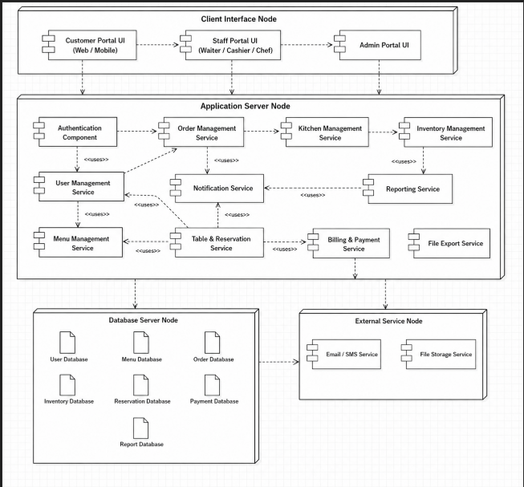

Descripition:

This component diagram shows the structure of the system divided into client interface,
application server, database, and external services. It illustrates how different components
like order management, menu management, billing, and kitchen services interact with each
other. The diagram also shows dependencies and data flow between modules to ensure
smooth restaurant operations.

7.Deployment Diagram

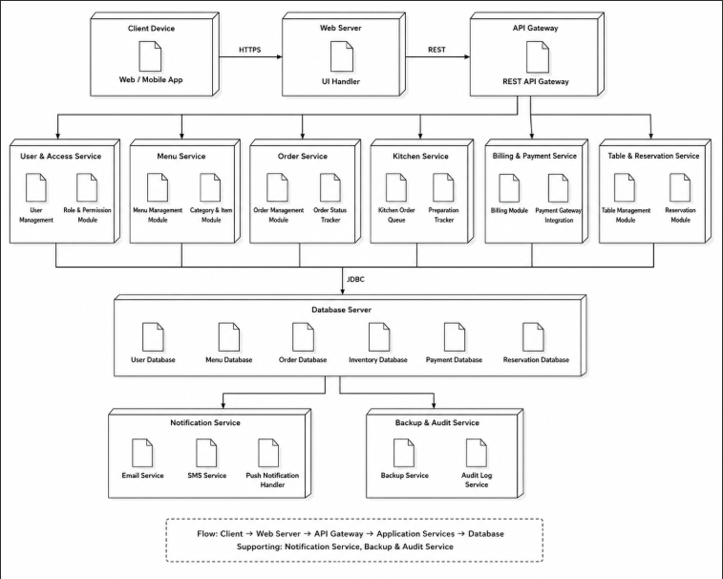

Descripition:

This deployment diagram shows the overall system architecture, including client devices,
web server, API gateway, and different service modules like order, menu, billing, and kitchen
management. It also includes a central database server and supporting services like
notification and backup. The diagram explains how different components interact to manage
restaurant operations efficiently.

10.Data Flow Diagram (DFD)

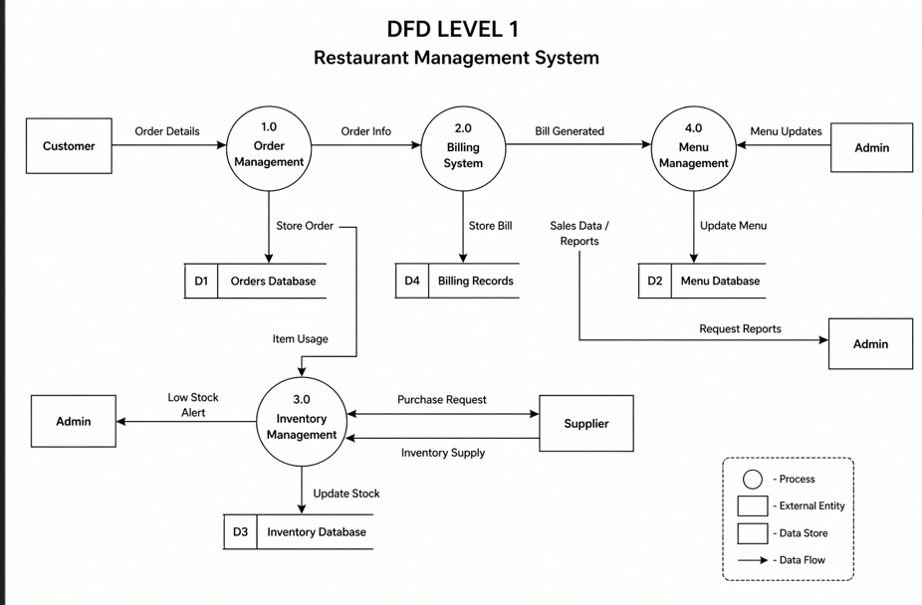

Descripition:

The diagram illustrates a Restaurant Management System using both Level 0 (context) and
Level 1 data flow diagrams. It shows how external entities such as customers, waiters,
kitchen staff, and administrators interact with the system. The Level 1 diagram further
divides the system into processes like user management, order handling, kitchen processing,
inventory control, billing, and report generation. Data flows between these processes and
databases ensure efficient management of orders, payments, stock updates, and system
reports.

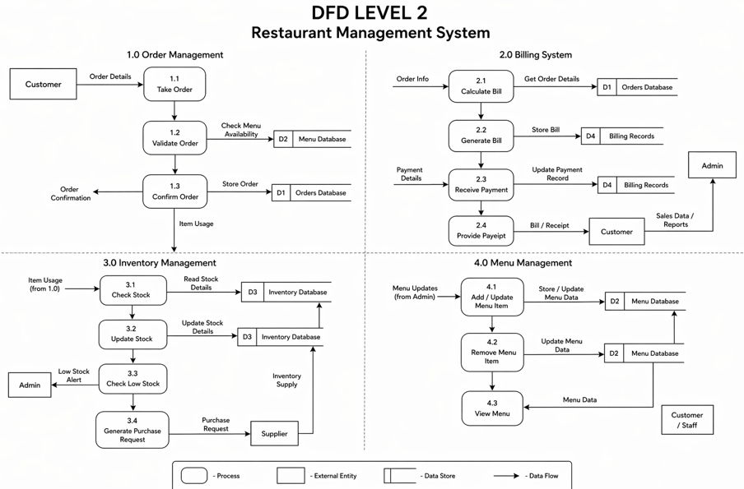

11.Control Flow Diagram

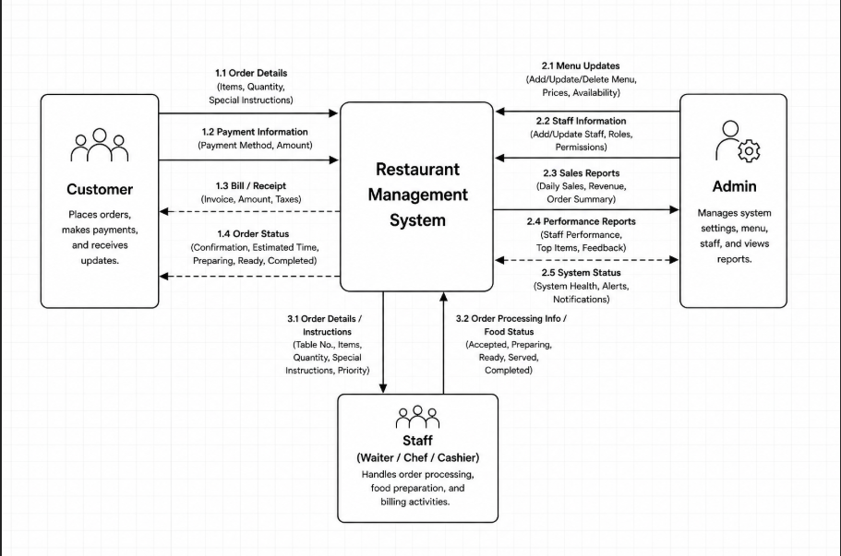

Descripition:

The Control Flow Diagram (CFD) for the Restaurant Management System illustrates the
overall system workflow starting from user login and validation. After successful login,
users access the dashboard to perform various operations such as menu management, order
processing, billing, inventory management, and report generation. Each module handles
specific tasks like taking orders, managing staff, processing payments, and updating
inventory. Finally, the system ends with logout, ensuring secure and organized restaurant
operations.

12. Conclusion
The Restaurant Management System provides an efficient and organized approach to
managing restaurant operations. By digitizing processes such as order management, billing,
able management, and payment processing, the system reduces manual work and minimizes
errors. It improves coordination between staff and kitchen, ensuring faster service and better
customer satisfaction.
Additionally, the system improves data management and accessibility, allowing
Administrators to monitor sales, orders, and staff performance effectively. Its user-friendly
interface and scalability make it suitable for small and medium-sized restaurants. Overall,
the Restaurant Management System enhances operational efficiency, improves service
quality, and helps restaurants deliver better customer experience.

13. References
• Articles from Google Scholar related to restaurant management and order management
systems

• Technical papers from IEEE on system design and software engineering
• Online tutorials and documentation related to web development, databases, and system
implementation

• Study materials and lecture notes on Software Engineering and System Analysis

